


Workbook Overview & Guidelines
This workbook is a structured guide for students to follow as part of Problem Solving in Engineering (PSE) – IP-3 Experiential Learning Course
Follow the modules outlined in this workbook, you will adopt and practice systems thinking methodologies to solve real-world problems in a systemic manner.
Until now, you spotted a problem or a gap, you thought of an idea and you developed a prototype. The downside of this rushed problem solving is that the root cause of the problem is not addressed and hence the problem can recur or newer problems can appear. Metaphor recall – 10-headed snake.
Through this course we want you to choose a system to fix instead of a problem.
You will learn and apply Systems Thinking methods to formulate the problem and develop resilient, robust and sustainable solutions.

How to Use This Workbook
- Collaborative Teams: Work in mixed-disciplinary teams of 3-5 team members.
- Active Writing: Use the fillable workspace to document your team's discussions, data, models, design and new system design architecture.
- Technology Agnostic Philosophy: The work book is generic and not bound to a disciplinary domain. It will guide you with methods and tools. You are expected to build your system awareness and expand your understanding by referring to links at the end of each module and apply them to your specific case.
- Iterative Progression: You will begin with Module 1, but the progress is not intended to be linear from module 1 to 6. It is recommended that you move back and forth from Module 1 to 4 as per your research and investigation. The best results will come if you do not remain stuck in a module. Keep the momentum alive and progress to subsequent modules while keeping an option open to come back and work on previous modules.
- Process over Product: In your first iteration of the workbook, you will develop the abilities to think in systems. Your solution may not be the best fix. The goal is to learn how to adopt systems thinking and rapid prototyping, not to create a flawless product. Continue the journey of PSE and you will be able to propose better system fixes in your next round of iterations. You can start with a fresh workbook.

Gen AI Usage Guidelines

- Establish context: Introduce yourself with your role in the project, project objectives and expectations and limitations that warrant use of AI
- AI Roleplay: Define what role will AI play in this partnership, e.g.
Assistant/Critique/Writer/Advisor/Peer-Reviewer/Subject Matter Expert of [ ]
- Set Scope: Specify AI deliverables and expectations clearly, some examples;
◦ Cite sources
◦ Exclude opinions not backed by strong evidence
◦ Restrict all references to count of [ ] citations or published journals
◦ Support information with reasoning
◦ Provide data but do not analyse and draw conclusions
◦ Skip ice-breaking sentences and do not bring social human-like flavour to the responses
◦ Provide contradicting perspectives as an unbiased observer
◦ Question my assumptions and ask for my reasons to my claims

Affected System (Problem Area) Selection
Identify a problem area or affected system that you would like to take up as your project in PSE (IP-3).

Select a Super System
For example: Transportation& Sustainable Mobility System

Select a Specific Sub System (Problem Area) to focus on:
For example: TGSRTC – Telangana State Road Transport System – Specific Location: Hyderabad.
Specific Issue – Protests
Specific Focus – Driver and Conductor

Problem Area if identified (Describe the local pain point in 2-3 sentences):
For example: TGSRTC Driver and Conductor Health Condition - TGSRTC has faced
protests over long working shifts (12-15 hours) of the drivers and conductors and the impact on their physical and mental health.

Module 1: Drafting the Project Informatics Document (PID)
Scoping Real-World Challenges and Building the Project Informatics Document

Module Targets/Outcome
- Scope a specific, localized problem within India (for e.g., Hyderabad IT corridor, rural Telangana).
- Formulate a Project Informatics Document (PID) establishing system boundaries, stakeholders, and physical interfaces/data baselines.

Study the System where the problem is observed
Describe what is happening in the System. Use 5W2H suggested below to guide your inquiry.
Please Note: This is an As-Is State representation and should NOT be mixed with the “should be” state.
Collect all the background data about the problem area from official sources. (e.g., citing reports from NITI Aayog, MoHUA, or local municipal bodies), web based links, news articles, research papers, reviews, stakeholder interviews etc.
The data or information is inadmissible if the sources are not cited All the claims must be backed with evidence. No evidence, No Claim At the end, your PID must have a statistical base and facts and figures.
Keep in mind:
- Are the sources official, recognised and citable?
- Is every claim backed by facts and figures?
- Is there enough measurable/quantified content to draw conclusions?
- If there are multiple sources citing conflicting claims, which ones would you refer to and what conclusions would you draw from the conflict?
- What are the associated assumptions?
- What variables influence the observed claims? What changes when the variables change and is there enough evidence to this?

Important Note: Keep your choice of technology area out of the context at the time of drafting PID. The focus is on the Problem area and evolving a deeper understanding of the system in which the problem exists. Do NOT investigate with a pre-conditioned mindset that you know the problem. Capture Symptoms and the context around the symptoms but do not associate it with an assumption which cannot be validated with data. You do NOT know the real problem yet.

5W2H Strategy relevant for PID
WHAT is/are the SYMPTOMs (Effect) of the problem observed?
WHO is affected most by the problem? (Stakeholder group 1) (List all)
WHO is Causing the Problem? (List all if applicable) (Stakeholder Group 2)
WHEN (Time patterns) is the Symptom happening? (Should contrast with the times when the symptoms are not occurring)
WHERE (Space context) is/are the symptoms observed? (Should eliminate the locations where the problem does not occur)
HOW is the process cycle observed? (How does the information or data move from one state to another?) (Draw a life cycle diagram or a flow chart)
HOW MUCH is the impact? Each claim above must be backed by the data/statistics. Provide count and cost.

Instructions:
Use this space to record all relevant observations, facts, statistics, stakeholder inputs, reports, research findings, and other supporting information related to the selected problem area. Focus on collecting information rather than analysing it or proposing solutions.

Write the Problem Statement (preliminary)
State the Problem in less than 100 words. This is your current understanding of the problems observed in the System. In case of multiple problems observed, mention as many as you have observed.
- Are these problems related to each other?
- What is the Causal relationship between the problems?
- Which one problem do you observe to be the cause of other problems if they are found related?
- Is there an obvious vicious loop (feedback loop) that causes the problems to compound?

Define the System
List all the components of the System. Each component is defined by its function.
For example; a part could be the role a person plays and not the name of the person itself. A Part could be a Smartphone User Interface, Installed Applications, Camera, Phone User, Retail shop, Price, Model etc.
After you have listed all components that you can think of, connect components to each other to indicate the relationships between the components and form a System map. The connectors could be one-way or two-way arrows suggesting how the components interact with each other. For better understanding the relationship can be written on the connector.
Watch the Video “Understanding Systems” on Youtube with link provided at the end of the module

Example: System Map of a Drug Manufacturing supply chain.
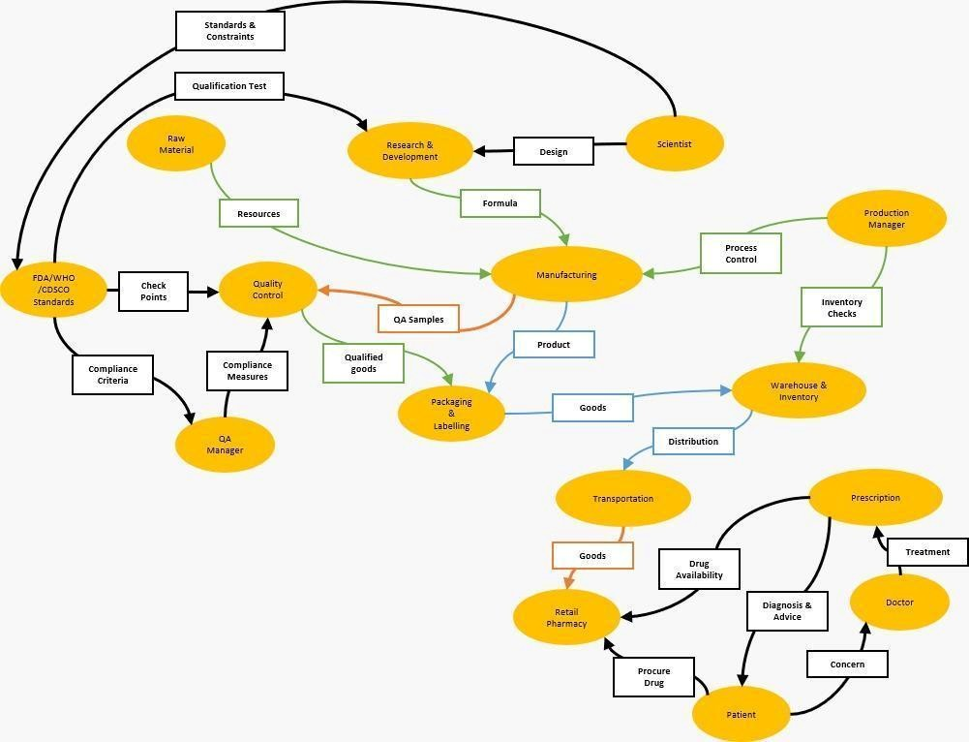

Define the System Boundary (Scope)

The system boundary defines what is included within the scope of your study and what remains outside it (the environment). The inputs drive the function of the system. The output from the system can be classified as desirable and not-so-desirable (waste) output.
Example given: System Map of a Drug Manufacturing Supply Chain System where the problem area focus is on supply chain from manufacturing to retail encircled within the system boundary depicted as dashed.

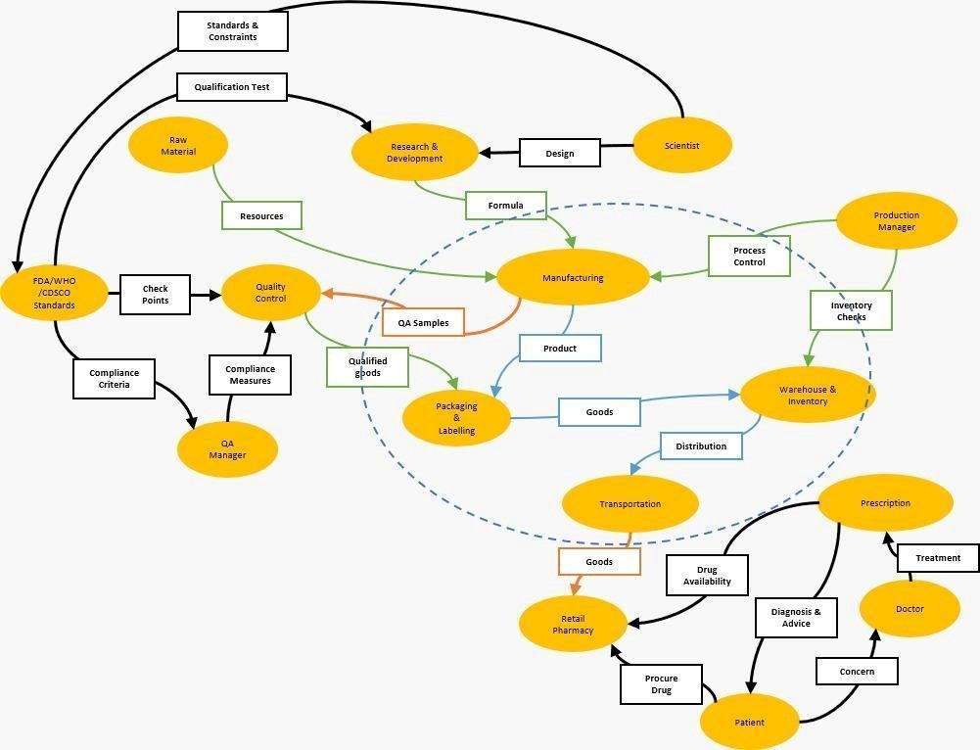
Inputs are identified as green arrows entering into the scope of your system from the environment and outputs are identified as red arrows leaving the environment.

Note: The dotted boundary will be the scope of the System which you will be working on.

(The scope of your system can be modified later to change the sub systems you intend to work upon.)

Stakeholder Map

Primary Stakeholder Map: List at least three distinct stakeholder groups and their primary needs.
For Example:
Stakeholder: Paddy Farmers
Need: Android mobile camera interface, localized voice-over output [Cite Source].

Note: If your project involves more than three stakeholder groups, you can always add additional entries.

- Stakeholder:
Needs:

- Stakeholder:
Needs:

- Stakeholder:
Needs:

Feel free to include more key stakeholders and their needs. Sometimes the stakeholders are not directly visible but they are critical to the system because they influence the system from far.

Quantitative Baseline Data: State at least two localized statistics or data points relevant to your problem from your PID. Cite sources.
For example:
Data Point: Mobile internet penetration in rural Telangana has crossed 68%, but network bandwidth in fields remains highly unstable (averaging less than 1.5 Mbps upload speeds in interior fields), making heavy cloud-based AI models completely unviable for real-time field diagnosis [Cite Source]

- Data Point A: e.g. Average daily traffic volume at the selected intersection is 18,500 vehicles per day, with peak-hour congestion occurring between 8:00 AM and 10:00 AM.

Source:

- Data Point B: for example the average waiting time at the traffic signal during peak hours is 4.8 minutes, leading to increased fuel consumption and delays.

Source:

Feel free to include more key data points. The data points help us to measure the success or impact of your suggested solutions by comparing “before” vs. “after”. Choose data points carefully because they must represent the real problem and you will ideate to improve these figures.

State “How Might We…”
Write three "How Might We" (HMW) statements that define the transition from the existing system to the desired system. Each statement should highlight the problem your project addresses and the improvement you want to achieve.
How might we move from (existing system or challenge) to a system that (achieves the desired outcome)?
For example: How might we compress a deep-learning crop disease classification model to run efficiently on low-cost Android smartphones with limited RAM and processing power?

- How Might We
- How Might We
- How Might We

Module 1 Resources & Reading Links/Video Links
- Thinking in Systems – Donella Meadows
- The Waters Center for Systems Thinking: waterscenterst.org
- Understanding Systems: https://www.youtube.com/watch?v=DVoy02xd2Mg

Video Chapters:
○ Complexity (00:00)
○ Hidden Patterns (02:17)
○ Wicked Problems (06:37)
○ Understanding the System (09:28)
○ Systems Thinking (17:37)
○ Zoom In & Zoom Out (27:48)
○ Long-Term Impact (28:50)
○ Feedback Loops (33:01)
○ Interdisciplinary Collaboration (34:52)
○ Applying Systems Thinking (35:44)
○ Modeling (Trends) (36:58)
○ Leverage Points (39:33)

Module 2: Systems Mapping & Root Cause
Dissecting Problems using the Iceberg Model and Stakeholder Ecosystems

Module Targets/Outcome
- Understand the problem better from the view of stakeholders and process flows.
- Apply the Iceberg Model approach to find the root cause of the problem.
- Differentiate between symptoms and real root causes of the problem.

Diving deep into the Root Cause Discovery (Iceberg Model).
Iceberg Model helps you to understand the problem at the root cause. This tool forces your team to look beyond the concern or symptoms that are visible at the surface (Event) to see the hidden patterns, recurrences and trends.
These trends (patterns) are a caused by the underlying code, databases, policies, environmental patterns, systemic structures or design limits (e.g., infrastructural, spatial, or physical limits) (Structures). Structure is how the various parts are organized and arranged in the system and how this organization of parts is causing the pattern of events to occur.
At the root of structures are user habits, cultural or design beliefs (Mental Models) that determine how structures are organized and why the system is the way it is.
In Summary, Mental models define Structure, and Structure drives the behavior of the system.

Zoom in to Your Scope Area
Focus only on the part of the system that is within your project scope.
Identify all the visible events, issues, or situations related to your chosen problem. These may be:
- The main problem itself.
- Events that happen just before the problem occurs (triggers).
- Events that happen as a result of the problem (effects).
- Other visible issues that are directly or indirectly connected to it. These visible events/issues can sometimes happen in different time or space but may have a possible connection to the main problem. The connection may not be so obvious but should be considered in the scope of investigation. For example; rising cases of lung cancer in Delhi do not appear to be linked to frequent gas leakage in air conditioners every summer, but they are both interconnected events due to the polluting gases in the atmosphere in the region.
Note: At this stage, do not try to explain why these events happen. Simply observe and list what you can see happening in the system.

Example:
If the selected problem is "Traffic congestion near a college gate", related visible events may include:
- Long vehicle queues during college hours.
Identify Events & Patterns:
Look at the events you have identified.
Some of these events may happen only once, while others occur repeatedly over time. Your task is to identify these recurring events or behavior and group them into patterns.
Look for similarities between the events and ask yourself:
- Which events happen repeatedly?
- When do they usually occur?
- Under what conditions do they occur? ● Is there an?
Note: At this stage, you are still observing the system. Do not explain why these patterns occur yet. The underlying reasons will be explored in the next step.
Example:
If the events include:
- Long vehicle queues during college hours.
The patterns may include:
- Traffic congestion occurs almost every weekday during college start and end times.
- The traffic congestion peaks during the start of the semester. It subsides during the summer break and holidays.

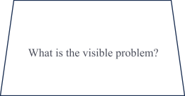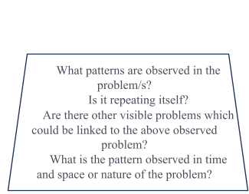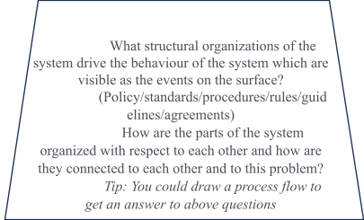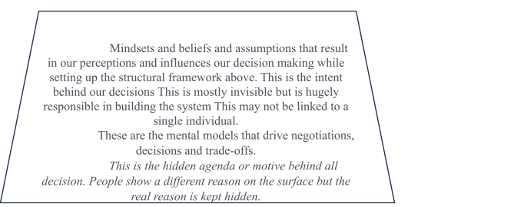

Stakeholder group identified from Module 1
Your system is influenced by more than just its users. Select 3 key stakeholders
Start by identifying everyone who interacts with, supports, influences, or is affected by your system. Consider different stakeholder groups such as customers, manufacturers, suppliers, partners, service providers, government agencies, and others relevant to your project.
Once identified:
- Gather their views through interviews or discussions.
- Identify what matters most to each stakeholder. ● Note their needs, concerns, and expectations.
- Identify what is negotiable and what is not.
Assign each member of the team, the role of one stakeholder each. Think from that stakeholder's perspective and summarize their needs, concerns, priorities, and expectations.
Note: AI can help you identify additional stakeholders or summarize common viewpoints, but always validate the information using your own understanding and research.

Map the Process & Lifecycle from the perspective of each stakeholder
Arrange the recurring patterns into a simple step-by-step sequence. This helps you understand how the problem unfolds over time.
Once the process is complete, identify the lifecycle by describing how long or how often the process continues.
Note: Focus on describing the sequence of events. The reasons behind this process will be explored in the next step.
Example:

Stakeholder Group 1: Students on Bike
Students Bikes arrive near University Gate – bike stops near the gate and pillion rider gets off the bike – bike rider looks for a space by the side of the road to park the bike under the shade of the tree. If the road side is occupied, the biker goes to the ground to park. The entry to the ground is right opposite the University Gate 2. At the same time several buses and private cars are entering the gate 2 from the same median. As soon as the space is available the biker turns on the ground and parks the bike. The biker then crosses the road to enter the University Gate 2.

Stakeholder Group 2: Private Car Drivers
Private cars arrive near University Gate – the cars have permission to enter the university through gate 2 which is right opposite the entry to the open ground designated as bike parking space. At the same time several students on bike are turning on to the parking grounds from the same median. Each bike has 3 or 4 students riding on it. As soon as the space is available the cars turn inside the gate 2. The cars have to wait for the pedestrian students and bikes to give space for them to turn Stakeholder Group 3: University Security Guards
The security guards have a duty every morning to keep the traffic moving and not hold the other commuters at all times.

Pattern
● Traffic congestion occurs every morning before classes begin.

Process
- Many vehicles arrive at the same time.
- Traffic congestion develops.
Lifecycle
- This sequence repeats every weekday during college hours

Identify the System Structure
Your process didn't happen by itself.
Something in the system allowed each step to happen.
Go through your process one step at a time and identify the parts of the system involved. Don't limit yourself to physical objects—rules, technology, infrastructure and environmental conditions are also part of the structure.
Example: Process
- Vehicles arrive.
- Traffic builds up.

Structures

- Road width, capacity and condition
- Entry and exit points on the road and the space between them
- Number of entry and exits on the road
- Number of buildings on the road side requiring access
- The pavement, it’s width and its condition
- The habits of people using the road ● Traffic signal.
- Different kinds of vehicles etc…

Explore Mental Models
Every stakeholder views the system differently.
After gaining clarity on the stakeholders’ views. Instead of explaining your own opinion, explain what your stakeholder would believe, expect, and value.
Once each team member has completed this activity, discuss the different viewpoints and identify:
- Common expectations. ● Conflicting priorities.
- Shared assumptions.
These insights will help you better understand why the system behaves the way it does.
Example:
 | Student on Foot | Student on Bike | Drivers in Car
Events/Patterns
Structure
Mental Model

Stakeholder: Security Guard
- Wants traffic to keep moving.
- Prefers students to follow traffic rules.
Stakeholder: Students on motorcycles
- Wants to manoeuvre through the traffic freely and safely.
- Don’t want cars to block them on roads.

Stakeholder: Students arriving in cars.
- Wants to arrive at college avoiding minor accidents.
- Don’t want motorcyclists to overtake them in peak hours.

Note: Don't limit your analysis to a single type of stakeholder. Consider at least three different stakeholder groups from different parts of the system (such as users, manufacturers, suppliers, regulators, service providers, or partners) to gain a broader understanding of the problem.

Review Your Project:
- Key Data bottlenecks identified.
- Key Process bottleneck identified
- Key Human bottleneck identified

Reviewing your “How Might we…” statement from Module 1.
How does your proposed HMW fix the bottlenecks?

For Example: How does your proposed simulation help find the optimal balance between these variables/ How does your proposed hardware design protect against these physical/electrical limits/ How does your proposed software
Bridge these broken links?
Which bottlenecks can be fixed with your HMW?

Complete the System Map
Developing a System Map is an iterative process.
At this stage, you may want to revisit your system map from module 1 and revise the system map with the new information discovered in Module 2. This will complete your System Map

Module 2 Resources & Reading Links
- Open The Waters Center for Systems Thinking: waterscenterst.org — Interactive guides and templates for the Iceberg Model and systems mapping
- Miro Online Templates: miro.com — Free digital whiteboard templates for Iceberg Model and Ecosystem mapping

Module 3: Causal Loop Diagrams & Leverage

Module Targets/Outcome
· Understand the core components of Causal Loop Diagrams (CLDs): variables, links, polarities (+/-), and feedback loops.
· Construct a localized CLD for a software-heavy engineering system.
· Apply Senge’s System Archetypes to identify strategic leverage points for digital/physical/embedded/ parametric or structural intervention.

Causal Loop Diagram:

A causal loop diagram is a simple visual representation of how different things in a system affect each other. Each factor is connected to another by an arrow, and the arrow tells you whether an increase in one causes an increase or a decrease in the other. These effects will eventually influence around the original factor again either positively or negatively. This forms a loop of factors that cause new factors that affect old one.

Components of a Causal Loop:

- Variables (nodes): Anything that can go up or down — population, temperature, sales, stress, workload, interest rate, etc. Every branch has its own examples.
- Arrows (links): Show cause and effect. An arrow from A to B means "A affects B."
- Polarity (+/–):
· "+" means they move in the same direction (Increase in A → Increase in B) · "–" means they move in opposite directions (Increase in A → Decrease in B)
- Loops: When arrows form a closed cycle, you get a feedback loop:
· Reinforcing (R): Keeps amplifying change
Ex: Social Media virality : More views → more shares → even more views
· Balancing (B): Keeps correcting change
Ex: Supply and demand : Prices rise → demand drops → prices come back down

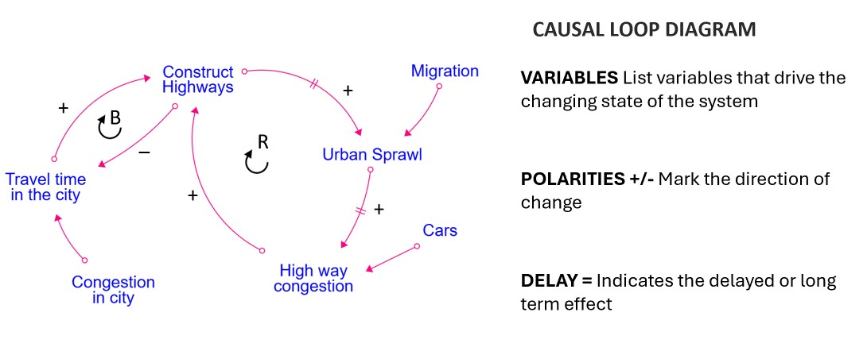

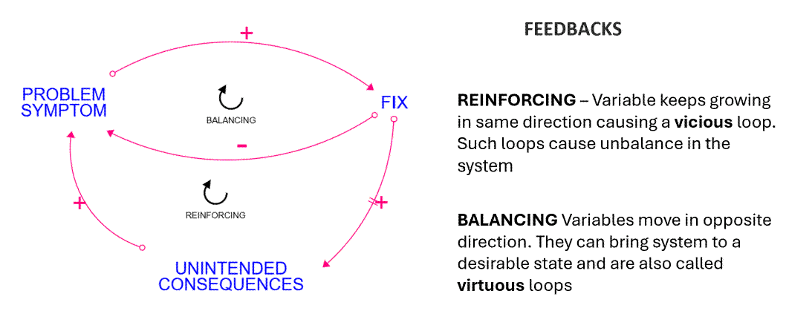

Identifying Feedback Loops
Identify at least one Reinforcing Loop (R) and one Balancing Loop (B) within your system. Then, pinpoint exactly where your HMW (How Might We) statement will intervene — this point is called the leverage point.
Steps to identify your loops:
- Find the Reinforcing Loop (R): Look for a chain of causes that keeps pushing the problem in the same direction — making it grow, worsen, or repeat without stopping on its own.
- Find the Balancing Loop (B): Look for a chain of causes that tries to correct or stabilize the problem — but may currently be too weak, slow, or missing entirely.
- Locate the leverage point: Identify the single spot in the loop where a small, well-placed change could shift the entire system's behaviour — this is where your solution (HMW) should act.

Leverage Points:
A leverage point is a place within a system where a small change can create a large shift in the system's overall behavior.
Steps to map leverage points on an already-drawn causal loop diagram:
- Study the existing loops — Go through the diagram and clearly label each loop as Reinforcing (R) or Balancing (B).
- Trace the problem's path — Follow the arrows to see exactly which loop(s) are driving the core problem you're trying to solve.
- Examine each variable/link — For every node and connection in the relevant loop(s), ask: "What happens if I change this?"
- Check for weak or missing balancing loops — See if a Balancing loop is too weak, slow, or absent — this is often a strong leverage point.
- Check for unchecked reinforcing loops — See if a Reinforcing loop is running unchecked — intervening here can stop the problem from escalating.
- Select the highest-impact, most feasible point — Pick the one where a realistic, small change is likely to shift the system's overall behavior the most.
- Mark it on the diagram — Clearly highlight/label the chosen leverage point directly on the causal loop diagram for reference.

Matching the System Archetype:

(Note: A system archetype match means finding the pattern that behaves most like your problem. Look at how your problem changes over time — growing, stalling, repeating, or worsening — and compare it to each archetype's loop pattern. Pick the one that matches your problem's actual behaviour, not just how it looks on the surface.)

  - Which archetype best describes your system problem?

  - Why does this archetype fit your problem?

SYSTEM ARCHETYPE REFERENCES

Archetype 1: Fixes that Fail
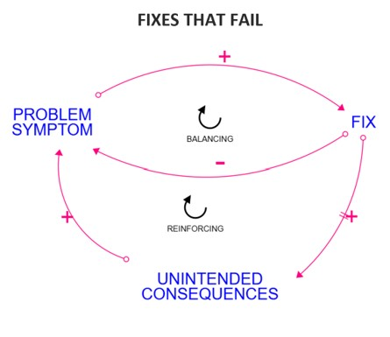
A QUICK FIX gives more power to the unintended consequences and the cycle continues.

Example: The Cobra Story from 1800s. The Britishers were struggling to invade the central regions of Indian continent due to their inability to deal with Cobras. They announced a sum of money to the locals who would capture and kill Cobras. The fix worked and the cobra population reduced for some time, only until the locals started breeding cobras to make more money and the cobra population increased again.

Archetype 2: Limits to Growth
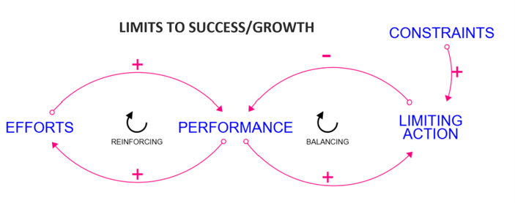
The limits to growth structure is based on the basic growth structure. And, as should be obvious, nothing grows forever as growth requires resources. Those required resources become a limits to growth

Example: People Express airlines is one of the best-known casualties of the “Limits to Success” archetype (see “‘Flying’ People Express Again,” November, 1990). Its tremendous growth was fueled by a rapid expansion of fleet and mutes along with unheard of low airfares. As the fleet capacity grew, People Express was able to carry more passengers and boost revenues, allowing it to expand fleet capacity even more (loop R3). The quality of its service was initially very good, so the positive experience of many fliers increased word-of-mouth advertising and the number of passengers.
The Dieting Bind
The “engine of growth” at People Express was seen as physical capacity — expanding fleet size, employees and routes. But its “limit to success” was service capacity — the ability to invest time and money in training its employees — which became more difficult to sustain as the company grew (loop R4).
The number of passengers flown eventually outstripped the airline’s capacity to provide good service. As a result, quality suffered and it began losing passengers (loop B3). When competitors began matching low rates on selected routes, People Express’ market competitiveness suffered even more. Focusing only on the reinforcing side of the structure turned rapid growth into a tailspin, contributing to the airline’s demise.
Simply hiring more employees was not the answer to People Express’ service capacity problems. Similar to the dieter’s reliance on intense exercise, it only masked the real need for the steady long-term commitment to hire and train the necessary people to bring service quality up to a high and sustainable level.

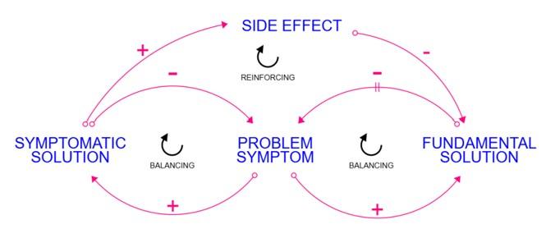
Archetype 3: Shifting the Burden

A shifting the burden structure occurs when there are different ways to address a situation. With one approach being easier, faster, and requiring fewer resources, which do you think gets pursued? The problem is that taking the easier path ensures one will have to take the easier path repeatedly, and makes it harder to pursue the long-term better solution.

Example: When you feel tired and take coffee or mid-afternoon caffeine to boost your energy. This results in more fatigue sooner. Another round of caffeine can help momentarily but the fatigue builds up, eventually reducing the amount of work you can do for the same amount of caffeine boost.

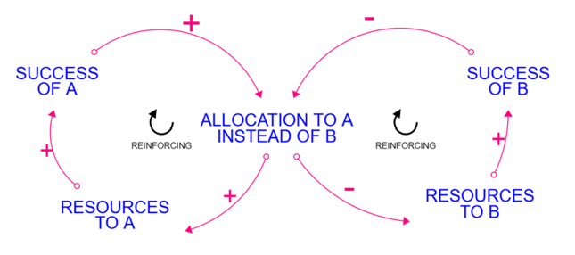
Archetype 4: Success to the Successful

Success to the successful archetype represents two reinforcing structures which may be in a delicate balance though as soon as one gains a small advantage the resource allocation favors the more successful and the result is then rapidly skewed in the direction of the more successful.

Example: Think of the Monopoly Board Game where the player with more resources is able to extract more from others. Rich people keep getting richer while the poor gets poorer when rich people have more access and means to pull more resources for themselves leaving less for others.

Archetype 5: Tragedy of the Commons
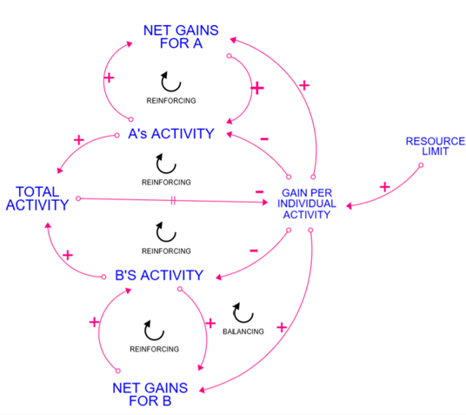
A Tragedy of the Commons situation exists whenever two or more activities, each, which in order to produce results, rely on a shared limited resource. Results for these activities continue to develop as long as their use of the limited resource doesn't exceed the resource limit. Once this limit is reached the results produced by each activity are limited to the level at which the resource is replenished

Example: When everybody takes the long detour to avoid traffic congestion, thinking no one will take that detour, ever heard of that?
And then the long detour becomes congested too.

Module 3 Resources & Reading Links
- Insight Maker: insightmaker.com — Free, open-source, browser-based tool for drawing CLDs and running system dynamics simulations.
- Loopy: ncase.me/loopy — An excellent, interactive open-source tool for creating thinking-in-systems simulations.
- Senge's System Archetypes Reference: https://insightmaker.com/tag/systemswiki — Quick-reference guide for common system archetypes and their leverage points.

Module 4: Divergent Thinking & Convergence
Brainstorming Interdisciplinary Solutions and Formulating the Solution Architecture

Module Targets/Outcome
- Conduct a divergent brainstorming session to generate multiple interdisciplinary solutions.
- Evaluate and select the most high-leverage solution using an Impact-Feasibility Metrics.
- Selected the solution plan with due diligence from all the disciplinary domains involving the solution design

Idea and Solution are different:
- Idea stage: Students brainstorm possibilities without worrying yet about feasibility.
For example, “Let’s design a water filter using natural materials.”
- Solution stage: Students test, refine, and implement the idea into something that actually works. For example, “We built a layered filter with sand, charcoal, and gravel that removes visible impurities.”
Here, the idea sparks creativity, while the solution demonstrates applied knowledge.
Systems thinking emphasizes that ideas are inputs, but solutions are validated outputs that fit into the larger system.
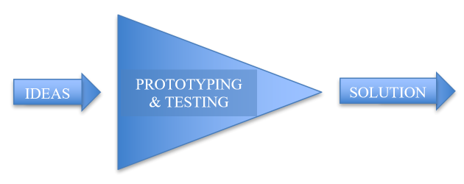
- Ideas encourage divergent thinking — many possibilities.
- Solutions require convergent thinking — narrowing down to what works.

Divergent Thinking – Generate Multiple Rapid Solutions
Conduct a Brainstorming session: Ensure every idea incorporates at least two engineering domains (e.g., CSE for backend, ECE for sensors, Mech for enclosure)
You are encouraged to write as many ideas as possible
For every idea generated, please answer the following questions:

Idea 1,2,3,4…..
- What problem symptom does it solve?
- What problem symptoms will still remain?
- What is the nature of your proposed solution?
  - New/Changed process?
  - New/Changed product?
  - New/Change Human Behaviour?
- Where is the Leverage Point? (At what point in the System will you intervene to deploy this idea?)
  - Is this treating the Symptom? (Event Fix)
  - Is this a Physical/Structural intervention?
  - Is this a cultural/paradigm change? (Mental Model Fix)

Associate an identifying number tag to all the ideas generated above Idea 1, Idea 2, Idea 3 and so on….

Convergence - Impact Metrics
In this section you will categorise possibilities generated in the last section to arrive at the most impactful and easy to implement ones



Rate your idea according to the above metrics. Write the Idea number in the corresponding quadrant.

Ideas which fix the symptom at the event level will remain on the left side of the metrics. Ideas that bring a long lasting change in the system, which do not depend on the people and their moods but which last even when the person moves out of the system will be on the right side of the metrics.
Ideas which have a small scale of impact and the resulting change in the system is minimum will remain in the bottom of the metrics and the ideas which will affect the system at a large scale will go to the top of the metrics.

List selected converged solutions based on the Impact Metrics
Which one or more ideas have you selected from the above and why?

Tip: A good selection is an idea which is Easy to Implement and has a High Impact in the System

Disciplinary Integration & Solution Architecture
Show how at least two different engineering domains interact via your solution.

Engineering Domain 1 (e.g., ECE/Sensors/Mechanical/Civil):
- What part of the solution requires technology competency relevant to this domain
Engineering Domain 2 (e.g., CSE/Data Science/Electrical/Electronics/Mechanical):
- What part of the solution requires technology competency relevant to this domain

Draw a block diagram of your Proposed System Architecture/Schematic/Simulation Diagram/Prototype plan: (Draw or block-diagram your inputs, connections, outputs).

Module 4 Resources & Reading Links
- Mermaid Live Editor: mermaid.live — Free, open-source markdown-to-diagram tool for generating flowcharts and architectures.
- Draw.io: app.diagrams.net — Free, open-source online diagramming tool with comprehensive template libraries.
- Figma (Free Tier): figma.com — Collaborative design tool for rapid wireframing and user interface layout mapping.

Module 5: Rapid Prototyping & Integration
Isolating the Critical Assumption & Building the Artifact

Module Targets/Outcome
- Isolate a single, high-risk technical assumption for your system.
- Set up and build your prototype
- Test the Prototype to match the desired HMW results.

Eliminating Identified Risks
- Narrow down your project's technical scope.
- Brainstorm all the technical assumptions required for your systems to work correctly without possible risk of failure
- Group them by Risk and Uncertainty.

Identify the single highest-risk, highest-uncertainty assumption. You will test your prototype for this assumption

- Our Single Critical Technical Assumption:

- The Success Metric: (At what data point/threshold the prototype is likely to pass and what is cut off to fail?

For example:
Users will have high-speed 5G
The database can handle 10,000 requests/sec
Our ML model can detect objects in low light
The sensor will read accurately in wet soil
The battery will last 24 hours
The relay can switch 230V AC safely without MCU noise resetting the processor
The check dam will not slide under maximum flood head
The municipal pipe pressure will remain positive at all tail-end nodes during peak demand hours
The average traffic delay will decrease by 30% if we implement adaptive signalling

Core Task: Prototyping
Build your Prototype
(For example: Write your code using open-source Python libraries OR Wire your circuit on a breadboard, connect your sensors and actuators OR Write a modular Python script to define your governing equations, establish parameter arrays, run a parametric loop, and plot the results using Matplotlib)

Test your Prototype and document the performance metrics below
Key Libraries/Components/Tools Used:
For example:
Pandas. NumPy, Arduino Uno R4 / ESP32, Matplotlib

Performance Test Results:

Show the Comparison table of the Data Points A & B (Module 1) with respect to the proposed solution

Impact/Performance  Metric | Before your solution | After your solution
Data Point A
Data Point B

Validation Conclusion:
Did the prototype meet your success metric?

What is the key technical insight gained from this prototype iteration?

What worked as per expected solution architecture?

Which experiments failed and why?

What changes were made to failed experiments to achieve desired performance/results?

What risks or assumptions exist in the current Prototype?

What will be the next System intervention to overcome the existing risks/manage assumptions/overcome prototype’s limitations?

